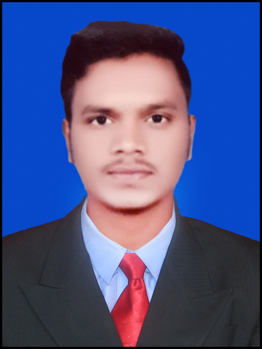

 +91 9405210295

 chavanmayur305@gmail.com

www.linkedin.com/in/mayur-chavan-48a505213

# EDUCATION

#### BACHELORE OF ENGINEERING

PUNE UNIVERSITY

**CGPA**- 9.57

# SKILLS

* **Oracle ERP:**  PL\SQL, Oracle Reports, Oracle Forms, Interface, Web- Adi
* **Programming:** PL/SQL , SQL
* **MS Office:** Excel, PowerPoint.

# CERTIFICATIONS

* Oracle Database Foundations**[Coursera]**
* Oracle SQL Proficiency**[Coursera]**
* Associate Oracle Cloud Infrastructure Foundations **[Oracle Certified]**
* Oracle SQL Basics **[Coursera]**
* Agile Software Development **[Coursera]**

MAYUR CHAVAN

**ANALYST/SOFTWARE ENGINEER**

Experienced **Oracle EBS technical developer** with over **2 years** of expertise in **Oracle Application R12** in **OM, PO, AR, AP, GL** modules. Proficient in creation, personalizing and customizing **reports (XML and RDF), forms , O2C & P2P** Cycles, **RICE** components and writing **PL/SQL** procedures, packages, and functions. Seeking to leverage my skillset and experience to drive technical excellence and deliver impactful solutions as a dedicated Technical Consultant.

# PROFESSIONAL EXPERIENCE

#### 1.Capgemini Technologies Service India Limited SEP 2022- Present

* + - Creation of new oracle **report**, personalization and customization of **forms** in **Finance, Order Management, Purchasing, Payables, and Receivables modules**, meeting specific business requirements and enhancing system functionality.
    - Created and optimized packages in **PL/SQL** to streamline business processes, resulting in increased efficiency.
    - Prepared detailed **Technical Design Documents** (TDDs) for support projects, ensuring a clear roadmap for implementation.
    - Worked closely alongside Functional team leads and business users to gather and grasp project requirements, effectively translating them into technical solutions.
    - Independently progressed the build of RICE objects from technical design documents to completion.
    - Resolved production issues in **AR, AP, OM, PO, GL** modules.
    - Demonstrated **expertise in PL/SQL** by developing and maintaining complex procedures, and functions, to support Oracle EBS applications.
    - Played a role in customizing **RICE components** to enhance system capabilities and meet business requirements.

**PROJECTS**

**Thales AMS 2023 [Oracle ERP] ( Capgemini)**

* + - As a part of technical team, we are providing ERP support to the multiple entities based on Europe.

# BADGES &TRAININGS

* **Oracle Apps** Training

•**Microsoft SQL** Training

• **Agile Software** Development

# SOFT SKILLS

•Adaptability

•Strong Communication skills

* Presentation skills

•Time Management

•Teamwork

**AWARD & RECOGNIZATION**

##  SPOT AWARD

* Received award for being: “Quick learner and quick turn around on SQL training.”[8.5/10 Rating]

# LANGUAGES

•English

* Hindi
* Marathi

## Developed and deliver new reports, form , interfaces as per client

## Requirement’s.

## As a part of technical team, we are providing ERP support to the multiple entities based on Europe including finance, purchasing,

## SCM module.

* + Successfully resolved **300+** support requests as a member of technical team within SLA.

## Specially worked on JIRA and Service now tool to resolve client tickets.

## Developed and delivered complex SQL , PL/SQL queries.

## Worked on technologies such as Web-ADI , Data Loader as Techno Functional member.

## Implemented rigorous quality control measures within PL/SQL packages, reducing errors and improving data accuracy. This contributed to higher data integrity and more reliable decision-making.

**2.Coditas Solutions JAN-2022 to June-2022**

**[Associate Software Engineer]**

* Primarily worked as **PL/SQL developer** with Microsoft technologies such as .Net, SQL etc.
* Worked on complex **SQL , PL/SQL quer**ies and normalization concepts to build strong relational database.

**PROJECTS**

**JOB SEEKER APPLICATION**

* Developed database using Microsoft SQL and used .Net MVC technologies to develop web application. [Capstone Project].

**ONLINE EXAM PORTAIL**

* Mainly worked as backend developer. Design and developed relational database using Microsoft SQL. [Training Project]